Product Datasheet
28-port Gigabit Easy Managed PoE Switch
(SWT-EMV28P24-U-4FO)
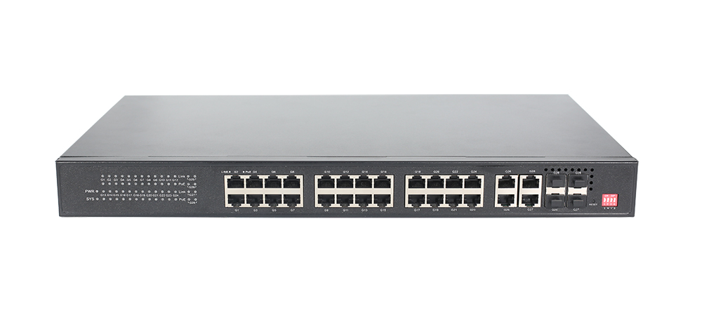
OVERVIEW
The SWT-EMV28P24-U-4FO is a Gigabit Easy managed PoE switch. It has 24*10/100/1000Base-T adaptive RJ45 ports and 4*10/100/1000Base-T uplink RJ45 and 4*1000Base-X uplink SFP fiber combo ports. Port 1-24 can support IEEE 802.3 af/at PoE standard and single-port PoE power up to 30W. As a PoE power supply device, it can automatically detect and identify powered devices that meet standards and power them through network cables. It can supply power to PoE terminal equipment such as wireless AP, IP camera, Internet phone, video door intercom, etc. through a network cable to meet the network environment that requires a high-density PoE power supply. It is suitable for hotels, campuses, factory dormitories, small and medium-sized enterprises, and cost-effective networking.
The SWT-EMV28P24-U-4FO can support Web management and NMS management platform to realize security network storm control, port management, VLAV configuration, remote operation and maintenance, and other functions. It has high reliability, is easy to install and maintain, has fast switching functions, and multiple access ports, and is suitable for accessing LAN devices of various sizes.

FEATURE
- Gigabit access, uplink RJ45/SFP combo port
- Support non-blocking wire-speed forwarding.
- Support full-duplex based on IEEE 802.3x and half-duplex based on Backpressure.
- Support Gigabit Ethernet port and Gigabit RJ45/SFP combo port combination, which enables users to flexibly build networking to meet the needs of various scenarios.

- Smart PoE power supply
- Remote PoE management function, port remote opening and closing.
- Comply with IEEE 802.3 af/at PoE standard, automatically identify PoE devices for power supply, and not damage non-PoE devices.
- 24*10/100/1000Base-T RJ45 ports can support PoE power to meet the needs of security monitoring, teleconferencing system, wireless coverage, and other scenarios.

- Extreme Optimization, minimalist application
- Real-time fault alarm and fault location.
- Remote upgrade, remote restart, and factory reset.
- Local platform and maintenance management.
- Visual network topology management, VLAN division, PoE control, port control, and switching capacity management.
- Practical network management functions are retained according to industry application requirements, and network deployment and centralized operation and maintenance can be quickly realized through the operation and maintenance platform.

- Innovative features
- Switch E to the ON position, and port 16-24 support 10M/250 meters transmission.
- Switch W to the ON position, turn on the network management function, enter the network management interface, and configure the required functions of the switch. After this function is turned on, all other dialing functions will be invalid and must be configured separately through management.
- Switch V to the ON position. Port 1-24 supports the watchdog function and automatically detects data communication status in real time. When port communication fails, the corresponding port PoE will automatically restart. Port 1-24 supports physical VLAN isolation functions to suppress broadcast storms. , improve network performance.
- Switch B to the ON position, and the storm suppression function will start port monitoring and implement traffic suppression and storm control, thereby limiting the traffic to a reasonable range and solving the problem of a large number of broadcast, multicast, multicast, and unicast (including unknown unicast) in the network. ) data frames cause problems such as network slowdown, data transmission timeout, data transmission congestion, and massive packet loss.

- Stable and reliable
- CCC, CE, FCC, RoHS.
- The user-friendly pane can show the device status through the LED indicator of PWR SYS, Link, L/A, and PoE.
- Low power consumption, with fan, galvanized steel casing, and excellent heat dissipation ensures the stable operation of the switch.

TECHNICAL SPECIFICATION

Model | SWT-EMV28P24-U-4FO
Interface Characteristics
Fixed Port | 24*10/100/1000Base-T PoE ports (Data/ Power)  4*10/100/1000Base-T uplink RJ45 ports (Data)  4*1000Base-X uplink SFP fiber cmobo ports (Data)
Ethernet Port | Port 1-24 can support 10/100/1000Base-T auto-sensing, full/ half duplex MDI/ MDI-X self-adaption
Twisted Pair Transmission | 10BASE-T: Cat3,4,5 UTP (≤100 meters)  100BASE-TX: Cat5 or later UTP (≤100 meters)  1000BASE-T: Cat5e or later UTP (≤100 meters)
Optical Fiber Port | Gigabit optical fiber interface, default no included optical module (optional single-mode/ multi-mode, single fiber/ dual fiber optical module. LC)
Optical Cable/ Distance | Multi-mode: 850nm/ 0-550m, Single-mode: 1310nm/ 0-40km, 1550nm/ 0-120km.
Chip Parameter
Network Management Type | L2 (Web management, platform management)
Network Protocol | IEEE 802.3 10BASE-T, IEEE 802.3i 10Base-T, IEEE 802.3u 100Base-TX, IEEE 802.3ab 1000Base-T, IEEE 802.3z 1000Base-X, IEEE 802.3x
Forwarding Mode | Store and Forward (Full wire-speed)
Switching Capacity | 56Gbps (Non-blocking)
Forwarding Rate @64byte | 41.66Mpps
MAC | 8K
Buffer Memory | 4M
Jumbo Frame | 10K
LED Indicator | Power: PWR (Green), System: SYS (Green), Network: Link (Green), PoE: PoE (Red), Fiber port: L/A (Green)
Reset Switch | Press and hold Reset for 10 seconds and then release to restore factory default settings.
PoE& Power Supply
PoE Port | Port 1-24
PoE Management | Remote on/off of PoE ports, port power, and real-time status viewing
Power Supply Pin | 1/2(+) 3/6 (-)
Max Power Per Port | 30W, IEEE 802.3 af/at
Total PWR/ Input Voltage | 250W/ (AC100-240V)
Power Consumption | Standby<16W, Full Load<250W
Power Supply | Built-in power supply, AC100~240V 50-60Hz, 4.1A
Physical Parameter
Operation Temp/ Humidity | -20°C~+55°C, 5%~90% RH Non condensing
Storage Temp/ Humidity | -40°C~+75°C, 5%~95% RH Non condensing
Dimension (L*W*H) | 440*270*44mm
Net /Gross Weight | 2.85kg /3.7kg
Installation | Desktop, Wall mount, 1U/19” cabinet
Certification & Warranty
Lightning Protection | Lightning protection: 4KV 8/20us, Protection level: IP30
Certification | CCC, CE mark, commercial, CE/LVD EN62368-1, FCC Part 15 Class B, RoHS
Warranty | 3 years, lifelong maintenance.
Network Management Feature
Interface | Port status display, Port traffic statistics  Port duplex/ negotiation rate configuration  EEE Energy-saving and green Ethernet function  IEEE802.3x flow control configuration (Full-duplex)
VLAN | Port-based IEEE802.1Q VLAN configuration (4K)
Security | Broadcast storm suppression
Management | One-key recovery, Web Management  Mobile APP operation and maintenance management  NMS platform management (Local platform)
System | Web browser: Mozilla Firefox 2.5 or higher, Google Chrome V42 or higher, Cat5 and above Ethernet cable  TCP/IP, network adapter, and network operating system (such as Microsoft Windows, Linux, Mac OS X) installed on each computer in the network Cat5 and above Ethernet cable

DIMENSION
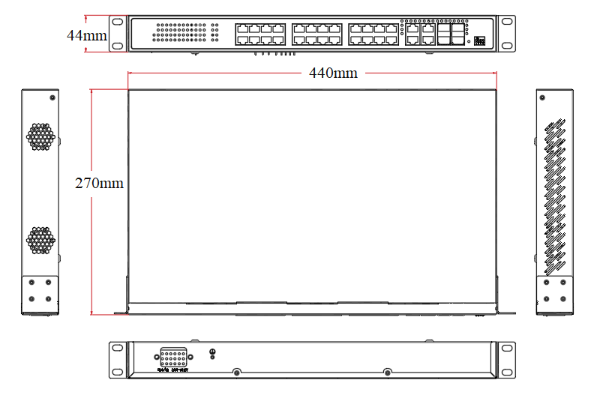

APPLICATION

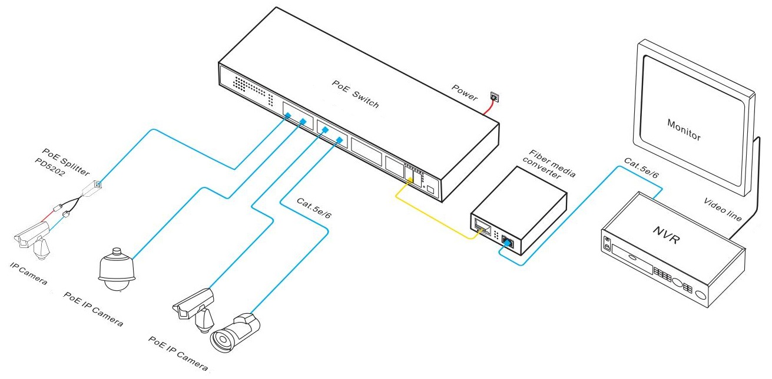

ORDERING INFORMATION

Model | Description | Built-in Power Supply
SWT-EMV28P24-U-4FO | Easy managed PoE switch with 24*10/100/1000M RJ45 ports and 4*10/100/1000M uplink RJ45 ports and 4*1000M SFP fiber combo ports. Port 1-24 can support IEEE 802.3 af/at PoE standard. It built-in power supply and desktop and 1U/19” cabinet installation. | 250W
Note: The optical module is not included and needs to be purchased.

PACKING LIST

Packing List | Content | Qty | Unit
Packing List | 28-port Gigabit Easy managed PoE switch | 1 | Set
Packing List | AC Power Cable | 1 | PC
Packing List | User Guide | 1 | PC
Packing List | Warranty Card and Certificate of Conformity | 1 | PC

OPTICAL MODULE

Product | Model | Description | Unit
1.25G  Optica  Module | 2630 | SFP optical module, 1.25G multi-mode dual fiber 850nm, transmission distance: 550m, LC interface. support DDM function and hot plugging. | PC
1.25G  Optica  Module | 2632 | SFP optical module, 1.25G single-mode dual fiber 1310nm, transmission distance: 20km, LC interface. support DDM function and hot plugging. | PC
1.25G  Optica  Module | 2612-T | SFP optical module, 1.25G single-mode single fiber TX1310nm/ RX1550nm, transmission distance: 20km, LC interface. support DDM function and hot plugging. | PC
1.25G  Optica  Module | 2613-R | SFP optical module, 1.25G single-mode single fiber TX1550nm/ RX1310nm, transmission distance: 20km, LC interface. support DDM function and hot plugging. | PC
1.25G  Optica  Module | 2612-T-SC | SFP optical module, 1.25G single-mode single fiber TX1310nm/ RX1550nm, transmission distance: 20km, SC interface. support DDM function and hot plugging. | PC
1.25G  Optica  Module | 2613-R-SC | SFP optical module, 1.25G single-mode single fiber TX1550nm/ RX1310nm, transmission distance: 20km, SC interface. support DDM function and hot plugging. | PC
Power Module | 2633 | 1.25G SFP optical module transfers to 10/100/1000M RJ45 port. | PC

